Where does this 95.2% come from?

David Ogilvy in Confessions of an Advertising Man wrote that 8 out of 10 people will never move past the headline. This is broadly supported by two recent studies demonstrating that 60% of people will share links without clicking on them. Another way to look at that is that 60% of the time, the headline is all that is consumed.

The headline is the market. If you are going to use a misleading title to purposely draw in readers and educate them, the reality is that you are actually misinforming 60% of the people interacting with your story. So right from the start, you’re already doing more miseducation than education. It’s also probably a larger miseducation impact than this as well since the study only accounted for “shares” and not people who saw the post on social media and didn’t share it.

There’s a positive, though, right? We’re still drawing in 40% of readers and educating them.

Well, no. It gets worse. The second of the two previous studies also found that of those that did read past the headlines, 30% *never* went in-depth on the article, and 50% didn't if it wasn't "breaking news." What does this mean for our goal of educating the public with misleading headlines? We can safely assume that 80% will never read in-depth enough to actually have the misinformation from the title corrected. Okay. 60% misinformed. Plus 80% of 40% (which is 32% of the original 100%) misinformed. So far we have misinformed 92% of our potential readers with our hyperbolic headline. But we can still educate 8%, right?

Probably not. That previous study was self-reporting. Eye-tracking studies have shown that 97% of participants will read the headline and 60% will glance over (not read) the article body and spend something like 30 seconds in total. Now there are correlation problems with this research in terms of "in the wild" behavior since everyone feels like they have to read the article in the study, but it's interesting that even when folks feel like they *have* to read the article, 40% still don't and most just glance over it. So it’s possible that of the 20% above who actually read your article, 40% still just glanced over it (which is 3.2% of the original 100%).

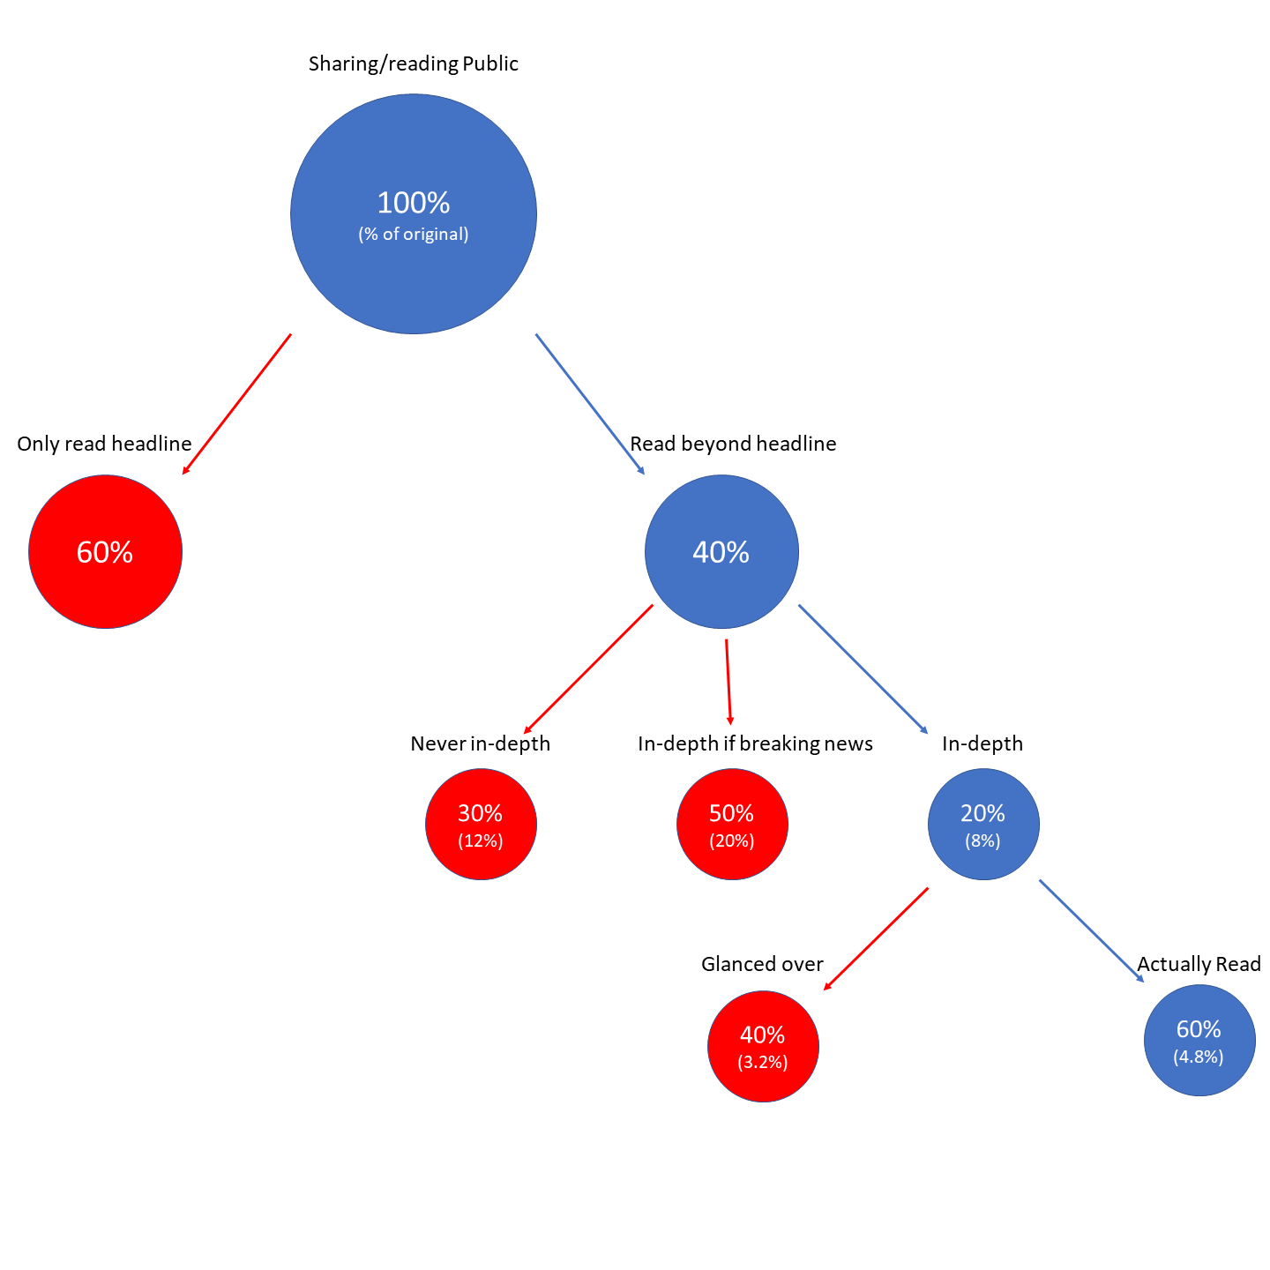

Okay. So how does our edutainment approach fair? In the end, based on how people *actually* consume information, our title miseducated 95.2% of people who interacted with it. At best, only 4.8% were actually educated enough that the misconceptions in the title were erased.

The idea that we can use titles disconnected from the essay just to draw folks in creates and reinforces a world of false ideas and concepts. Let’s go back to the American Archaeology Magazine webarticle. As of October 5th, 2018, 4,373 people had clicked on this page and been brought to the website. Since people who click on an article only account for about 40% who interact with the headline, that means that another 6,560 people or so were definitely misinformed because they never got to the actual story. Of the 40% (4,373) who read the article, 80% (3,498 people) didn’t move past the headline and a brief skim. Then, with the last 20% (875 people) who actually read the article, 40% (350 people) still just glanced over it. So out of an interaction audience of approximately 10,933 people, the article and headline managed to educate 525 people and misinform and reinforce some pernicious ideas for 10,408 people.

Let’s be clear hear, because this isn’t that the headline allowed us as research based educators to educate about 500 people out of 11,000 while not educating the remainder. No. Instead while we did educate those 525, we actively miseducated about 20 times as many people.

So how damaging are these headlines? “Why 536 was ‘the worst year to be alive’” was only bad for people in Europe and the Near East. Yet this headline treats European and Near Eastern history as global history and erases all other societies at that period. How many people does it do that for? On November 21st of 2018, approximately 37,000 people had interacted with this on Facebook. So this title erased all non-European and Near Eastern history as unimportant for 35,224 people. About 1,800 would read the story and find out that details. Using the graph.facebook.com function (on 11/21/2018), we can look at facebook shares (not likes, though) to see how damaging these headlines are for webpages that don’t publish numbers. “Why Did the Clovis People Mysteriously Vanish?” miseducated 2,293 people and educated 116.

And these numbers don’t even include folks who saw the headline in their newsfeed but didn’t like, share, or click on it.

I think it’s pretty clear at this point that if your goal is to educate, dramatic clickbait headlines do the exact opposite of what you want them to do. If your goal is to simply increase your viewership, or interactions, then they are quite successful.